# Significant data structures

The data structures that will mainly be used on the Android application are ArrayLists. The reason ArrayList has been chosen over an Array is because, in Java an Array is a fixed length data structure whereas an ArrayList is a variable length Collection class. This means the ArrayList will re-size itself when it reaches its capacity. This is required because the size of the arrays we will be using will not be known until after elements have been entered into it.

## WalkLocation

An object of the WalkLocation class will hold variables which contain data about the current location the user is at, such as:

* coordinates
  + The latitude and longitude value of the location.
* name
  + The name given to the location by the user.
* description
  + A description of the location given by the user.
* photos
  + An ArrayList of images for the current location.
* timestamp
  + The date of the current moment when the creates the current WalkLocation object.

## Walk

An object of the Walk class will hold variables which contain data about the walk tour the user created such as:

* title
  + The name given to the walk tour.
* shortDescription
  + A short summary of the walk tour.
* longDescription
  + A full description of the walk tour.
* locations
  + An ArrayList of WalkLocation objects.

## Class Diagram

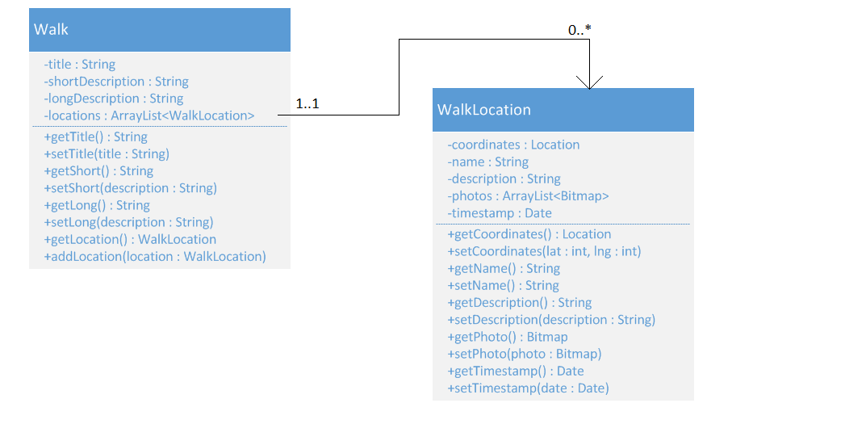

# Object Diagram

